**Network Security Assignment -1**

Anirudh Reddy K

AP21110011342

**Q.1) List the different protocols that appear in the protocol column in the unfiltered packet-listing window in wireshark GUI**

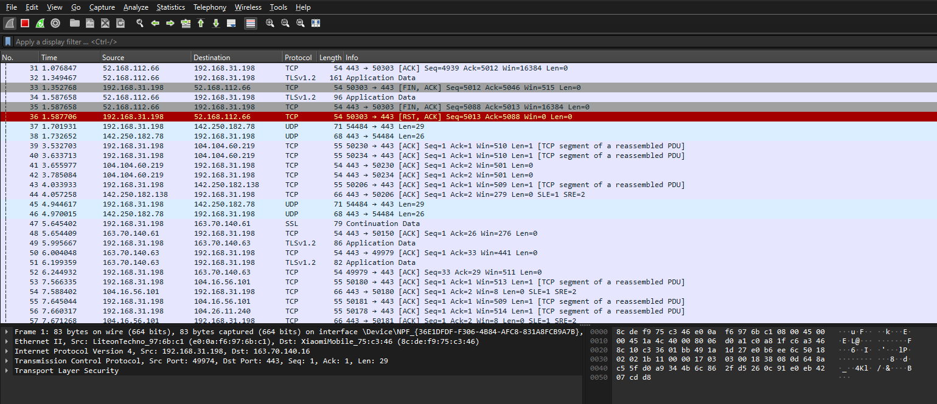

The basic protocols that I observed in the protocol column in the unfiltered packet-listing window is TCP,TLS,HTTP,DNS protocols. The majority of the protocol which is observed more is TLS protocol since the websites that we browsed are https protected websites

**2) How long did it take from when the HTTP GET message was sent until the HTTP OK reply was received for the webpage you visited in your web browser? (By default, the value of the Time column in the packetlisting window is the amount of time, in seconds, since Wireshark tracing began. To display the Time field in time-of day format, select the Wireshark View pull down menu, then select Time Display Format, then select Time-of-day.)**

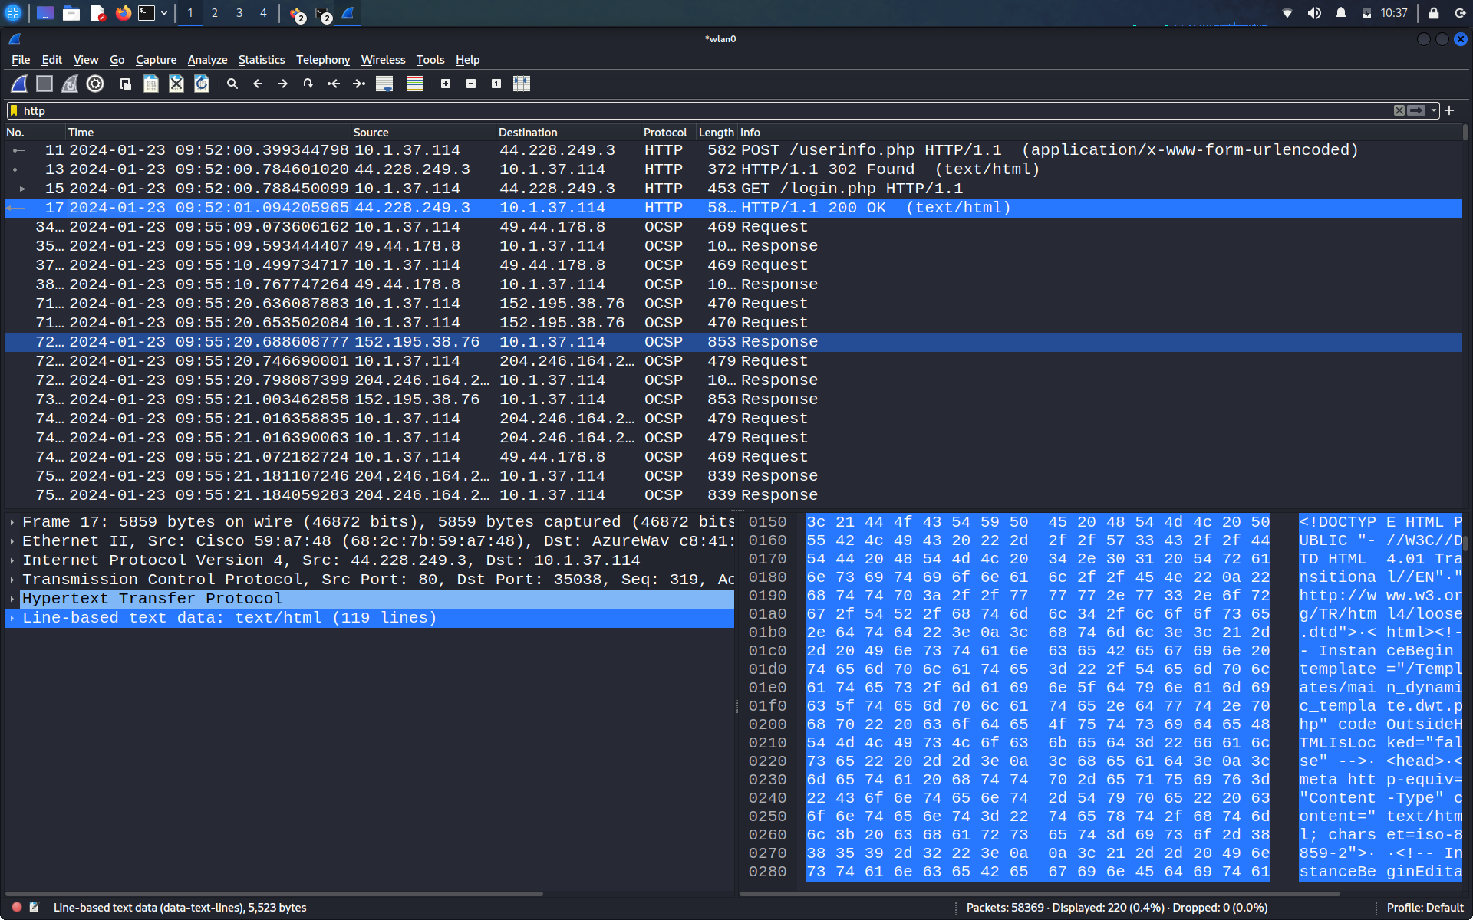

As mentioned in the above screenshot, The time difference between the get request and the ok request is 0.4 seconds.

**3) What is the Internet (IP) address of the URL you visited and what is the Internet address of your computer?**

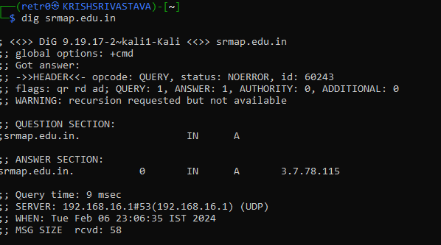

Using dig command I found the server IP address and after that I filtered the ip address with the command ip.src == 9.19.17.2

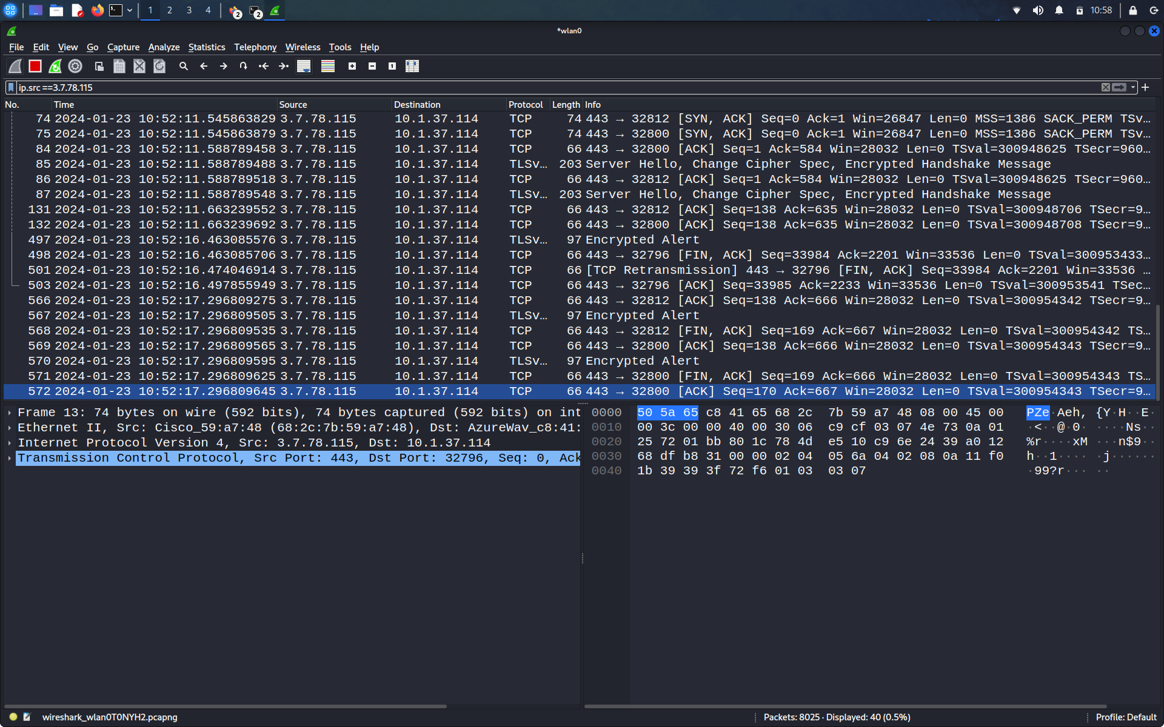

**4) Print the two HTTP messages displayed in wireshark GUI after you had visited above URL through your web browser. To do so, select Print from the Wireshark File command menu, and select “Selected Packet Only” and “Print as displayed” and then click OK.**

The post request for the following wireshark http method when clicked print as displayed is:

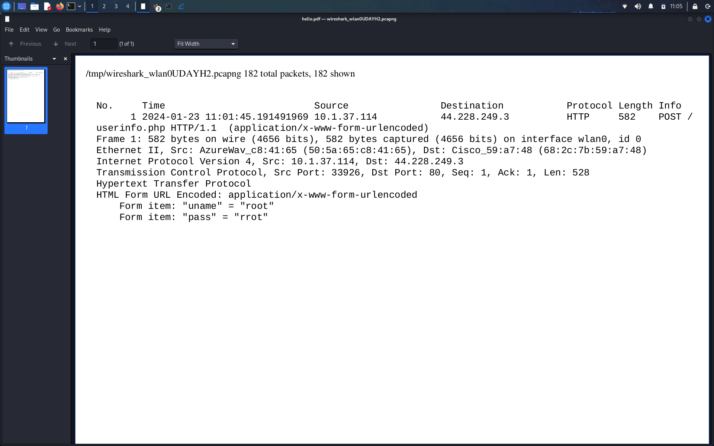

The ACK response when clicked print as displayed is:

